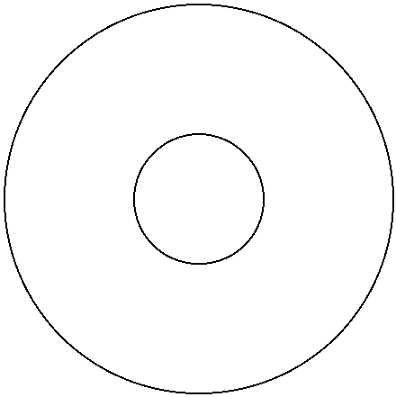

RECOGNIZING READER’S AFFECT

USING EEG DATA

MS in Computer Science

April 2017

KALAW, Kristine Ma. Dominique Ferrer

Mr. Ethel Chua Joy ONG

Thesis Adviser

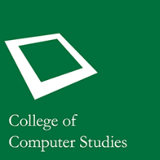

RECOGNIZING READER’S AFFECT

USING EEG DATA

MS in Computer Science

April 2017

KALAW, Kristine Ma. Dominique Ferrer

Mr. Ethel Chua Joy ONG

Thesis Adviser



RECOGNIZING READER’S AFFECT

USING EEG DATA

MS in Computer Science

April 2017

KALAW, Kristine Ma. Dominique Ferrer

Mr. Ethel Chua Joy ONG

Thesis Adviser



RECOGNIZING READER’S AFFECT

USING EEG DATA

MS in Computer Science

April 2017

KALAW, Kristine Ma. Dominique Ferrer

Mr. Ethel Chua Joy ONG

Thesis Adviser



RECOGNIZING READER’S AFFECT

USING EEG DATA

MS in Computer Science

April 2017

KALAW, Kristine Ma. Dominique Ferrer

Mr. Ethel Chua Joy ONG

Thesis Adviser



RECOGNIZING READER’S AFFECT

USING EEG DATA

MS in Computer Science

April 2017

KALAW, Kristine Ma. Dominique Ferrer

Mr. Ethel Chua Joy ONG

Thesis Adviser

